# Testing:

### User Story: Pending Placement – by Ma913

|  |  |  |  |  |  |
| --- | --- | --- | --- | --- | --- |
| **Test Case Type** | **Description** | **Test Steps** | **Expected Result** | **Actual Result** | **Status** |
| Functionality | Uploading a new form and making sure it is presented in the jsp file/showing in the page. | Go to the “newStudentUpload” page and uploading a new form into the database | The student details are showing in the “Pending placments” page | It did show | PASS |
| Functionality | When clicking on the Status buttons they despair and get tagged into the database as the chose button. | On the “Pending placements” page. Under the “Status” section click on any of the buttons | They despair and go into the database with the chosen button as a new information | It worked as expected | PASS |
| View | Not looking good needs, a table to present the information in a good shape otherwise it is confusing with so much data. | Look into the page | Easy to read information | Not easy to read. Hard to track which students the buttons are related to. | FAILD |

### User Story: Flagged Forms – by aamd1

|  |  |  |  |  |  |
| --- | --- | --- | --- | --- | --- |
| **Test Case Type** | **Description** | **Test Steps** | **Expected Result** | **Actual Result** | **Status** |
| Visibility | The page exist | Go to the URL of the page and see if the page load | The page loads | The page loaded | PASS |
| Functionality | Flagged placements are shown | Use the pending Placement URL to flag some placements then go the flagged forms page and see if the placements are shown. | The flagged placements are shown on the page. | The flagged placement loaded and showed. | PASS |
| Visibility | Reasons are shown | Use the pending Placement URL to add description and flag some placements then go the flagged forms page and see if the reasons appear | The reasons do appear. | The reasons for flagging placement do appear. | PASS |
| Functionality | Inconsistencies can be shown. | For any of the flagged user stories click on the student name and inspect the results | The fields for student and placement providers are shown side by side for reviewing. | The fields for student and placement providers are shown. | PASS |

### User Story: Student Information Preview – by aamd1

|  |  |  |  |  |  |
| --- | --- | --- | --- | --- | --- |
| **Test Case Type** | **Description** | **Test Steps** | **Expected Result** | **Actual Result** | **Status** |
| Functionality | Student information can be viewed | Go to the URL {domain}/students/{studentID} where studentID is any student number and inspect the result. | The fields for student and their placement providers are shown side by side for reviewing. | The fields for the student are shown. | PASS |
| Visibility | Student Information page can be access | Go to the URL {domain}/students/{studentID} and inspect whether the page loads up. | The page loads up. | The page loaded up. | PASS |

User Story: Statistical reports – By ma913

|  |  |  |  |  |  |
| --- | --- | --- | --- | --- | --- |
| **Test Case Type** | **Description** | **Test Steps** | **Expected Result** | **Actual Result** | **Status** |
| Functionality | The statistics are showing in a table based on the chosen filters | Tick on of the 3 available boxes and choose an option from the dropdown menu in front of each tick box. | The information to be presented showing the numbers and values based on the filtered options. | The statical information was presented, showing the values based on the filtered options. | PASS |
| Visibility | The statistics are showing in a table based on the chosen filters | Tick on of the 3 available boxes and choose an option from the dropdown menu in front of each tick box. | The information to be presented in a neat way and easy to read and understand. | The information was easy to read and well structured. | PASS |

User story: Nav bar – by ma913

|  |  |  |  |  |  |
| --- | --- | --- | --- | --- | --- |
| **Test Case Type** | **Description** | **Test Steps** | **Expected Result** | **Actual Result** | **Status** |
| Functionality | The navigation-bar is a feature that is placed in all the pages that require login by the tutor or placement team to allow them to be able to easily navigate through out the different pages of the website. | Login into the website, you would be able to see it at the top of the page. There are 4 buttons on the top right corner, 2 of them are dropdown menu with more links to pages, one is the report page, and one is logout button. | The expected result is to be redirected to whatever page I click the button for from the navigation bar. | After clicking you get redirected to the page you clicked the button for. | PASS |
| Visibility | The navigation-bar visibility is nice and clean. Forms are all tagged under one dropdown menu. Placements related are under a dropdown menu, report and logout buttons are individual. | Login into the website, you would be able to see it at the top of the page. There are 4 buttons on the top right corner, 2 of them are dropdown menu with more links to pages (“Access Forms” and “Access Placements”), one is the report page, and one is logout button.  When you click on the dropdown menu buttons you will get all the related pages that you can have access to. | To see the navigation-bar clearly on the top of the page which clear title for the buttons and easy to read text and colour. | The navigation-bar is at the top of the page with clear text and colours making it easy to read and access. | PASS |

User Story: Data Import – by ma913

|  |  |  |  |  |  |
| --- | --- | --- | --- | --- | --- |
| **Test Case Type** | **Description** | **Test Steps** | **Expected Result** | **Actual Result** | **Status** |
| Functionality | The Data import takes old type data form (excel) and transfer it into the database. | Go to the “/ uploadDatabase”  Link to be able to upload a csv file. Click on “Browse file” button, then select your csv file then click on “submit”. | It validates each excel sheet and if there was an error it will inform the user what cell the error has and that they should change it. If there was no errors it will show a message saying that the file has been imported into the database. | It validates when the date was a string and referred to the exact cell. After changing the date cell information, it was submitted as excepted and showed the submission message. | PASS |
| Visibility | The data import page is very simple containing only 2 buttons. One for upload a file and the other to submit. There is only sentence in the page. One about what this page do and the other about what file type to upload. | Go to the “/ uploadDatabase”  Link to be able to upload a csv file and access the page. | The text is easy to read and understand the point of the page. The buttons are clearly located and easy to find and read the text of it. | The text is easy to read and understand the point of the page. The buttons are clearly located and easy to find and read the text of it. The colours and text size were good as well. | PASS |

### User Story: Help Page – by CS835

|  |  |  |  |  |  |
| --- | --- | --- | --- | --- | --- |
| **Test Case Type** | **Description** | **Test Steps** | **Expected Result** | **Actual Result** | **Status** |
| Functionality | All the links redirect to the expected webpage(s). | Visit the URL {domain}/HelpPage/HelpPage and click on all of the hyperlinks. | All the hyperlinks redirect to the website or webpage they are supposed to. | Only some hyperlinks redirect to the correct webpages. | FAIL |
| Visibility | Help page can be accessed | Visit the URL {domain}/HelpPage/HelpPage and see if the webpage loads. | The webpage loads. | The webpage loads. | PASS |

### User Story: Application Status Check – by CS835

|  |  |  |  |  |  |
| --- | --- | --- | --- | --- | --- |
| **Test Case Type** | **Description** | **Test Steps** | **Expected Result** | **Actual Result** | **Status** |
| Functionality | Entering Student Application Inputs | Visit the URL {domain}/public/ ApplicationStatusForm and click to input any of the textboxes. | Be able to fill out textboxes. | All textboxes are fillable. | PASS |
| Visibility | Student information can be checked. | 1. Visit {domain}/public/ ApplicationStatusForm 2. Enter student number, company name and Unique ID. 3. Click on check | A message is displayed indicating whether the application was received or not | A message is displayed which indicates the existence of the application in the database. | PASS |

# Reviewing:

# User story – Statistical Reports

By Zaina

Clearly structured code.

Comments are added to the classes and are clear

The drop-down boxes show the required result.

However when all the functions are selected the CSS looks a bit weird. There is not space at the bottom of the screen. The last table looks congested.

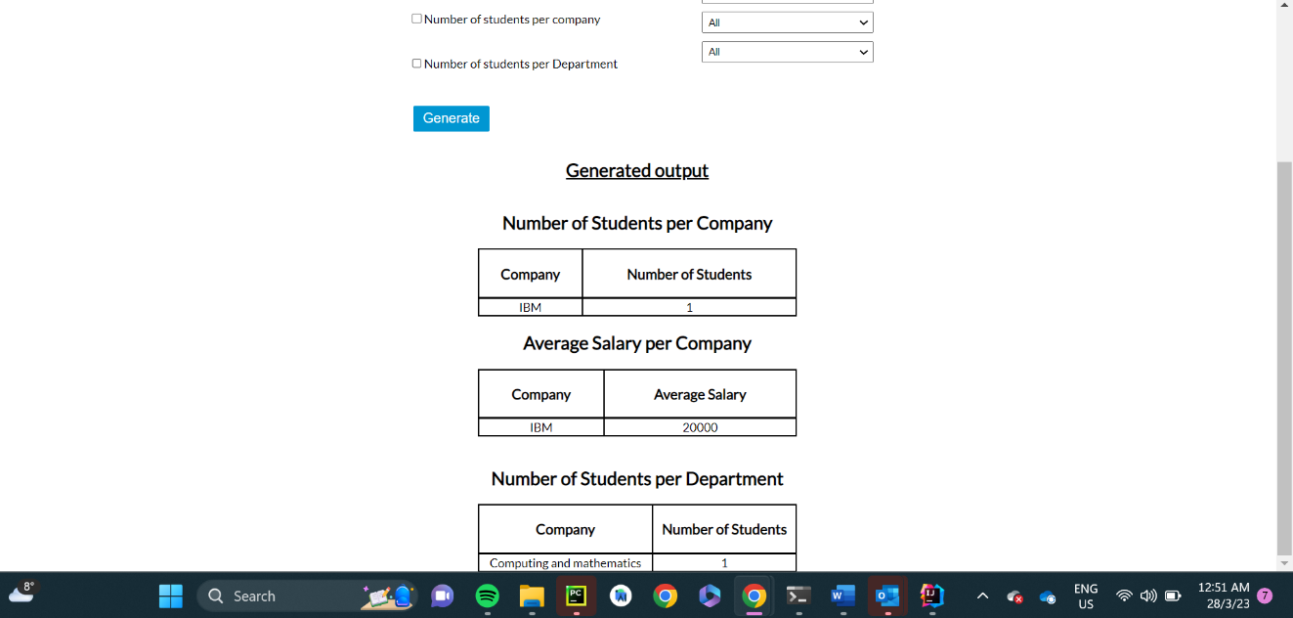

Other than that, good work!

### User Story: Student Information Preview – Bill

The code is neatly and clearly commented.

Contents of all related files are consistent and readable including the view and its layout.

Again, the codes are of a maintained high quality with other works produced; no practical problems found.

# User story – Help Page

By Zaina

The code is understandable and written well.

No spelling errors found.

The controller has been commented (I think you should try adding comments to the jsp as well)

The Help Page is readable, css looks neat

Overall, good work!

# User story – Application status check

By Maryam (reviewer)

Ran this code from main branch.

Went to public/ApplicationStatusForm, entered incorrect details, but when pressed submit, was taken to the “Are you lost?” page. The error on the console is :

“Resolved [org.springframework.web.method.annotation.MethodArgumentTypeMismatchException: Failed to convert value of type 'java.lang.String' to required type 'int'; nested exception is java.lang.NumberFormatException: For input string: ""]”

I think it can’t handle the Unique ID field being left blank. Validation should be added to make sure the submit button can’t be pressed unless it’s filled in.

Also when the error page does work, there should maybe be a return button available.

Added a comment to make it clearer how the student gets the unique id

Should have a comment at the very top of class indicating author and purpose of class (I added it in)

Naming convention for url links are not consistent e.g. /ApplicationStatusForm and /studentThankYou . I think it would be best to use the lower case version.

Your comments are very nice and professional, it’s also a good feature idea.

# User story – Navigation Bar

By Nina

* There are no comments added to the controller or jsp files.
* The layout looks great.
* CSS looks good too.



The “Report” looks like you are trying to report a problem in the website. Changing it to “Statistical Report” would make more sense.

# User story – Data Import – xlsx to Database

By Abdulqader (aamd1)

After accessing the import page and uploading a filled file the page I was redirected to another page where additional information was provided as shown in the figure below.

Inspecting code of the controller shows that sufficient and informative javaDocs were added to methods and functions. Moreover, the code have consistent naming convention where each cell is named “cell{cell number}” where cell number if the number of the cell in an individual row.

However, the code includes many print statements, one per cell which will fluid the server console and could cause the application to crash or temporarily lag.

The code handles many type of errors such as Null Pointer Exception and Not Office XML File Exception.

The navigation bar does not appear on “**/read_excel**” page which forces the user to go the main page in order to access the navigation bar.